10th September 2021
Curriculum Newsletter Term 1
Dear Parents/Carers,

Welcome back and to year 2! We hope that you have managed to have a relaxing summer holiday and that you are all ready to get back to some kind of normality. It has been lovely to welcome back the children and we are looking forward to having a wonderful year together.

We have got a busy year ahead! We will be spending time filling in any gaps that the children have following school closure last year. With a particular focus on phonics, writing and maths.

As we will not be able to do our usual ‘Meet the Teacher’ in the classroom this term, we have included all of the information that we would talk about in this letter.

Below is an outline of the curriculum we will cover in class this term.

Subject | Areas to be covered
Maths | We will continue to use Maths No Problem which is in line with the Singapore Maths approach. This encourages children to use manipulatives to support learning and approach mathematical problems in different ways. Children will also be developing their mathematical thinking in a range of contexts with particular focus on:  - Counting to 100  - Place value  - Comparing numbers  - Number bonds  - Number patterns  - Addition and subtraction
English | Dragons are everywhere in year 2 this term! We will explore The Dragon Machine, by Helen Ward, creating our own version of the story. We will be thinking about how we structure our sentences, developing our cursive handwriting and using adjectives for description.  Non-fiction writing will be developed within the context of our history work, based on the Normans and Tonbridge Castle. We will also be writing recounts so that we can use time connectives to sequence our ideas.
Science | In Science we will be looking at ‘Everyday Materials’ and answering the big question: ‘Which material is best for the bottom of our school shoes?’  The children will be able to:  - Distinguish between an object and the material from which it is made.  - Identify and name a variety of everyday materials, including wood, plastic, glass, water and rock.  - Describe the simple physical properties of a variety of everyday materials.  - Compare and group together a variety of everyday materials on the basis of their physical properties.
RE | Our RE learning this term will be about Creation, in particular, answering the big question, Who made the world?  Throughout the unit we will be exploring the answers to these questions:  What is the story of creation in Genesis 1:1–2.3?  How does ‘Creation’ fit into the ‘big story’ of the Bible?  What does the story tell Christians about God, Creation and the world?  What do Christians do to say thank you to God for the Creation?  What are our ideas and questions about living in an amazing world?
PE | PE will take place on Thursday and Friday this term. During term 1, the children will be working on their ‘hit, catch and run’ skills.
PSHE | We use a comprehensive PSHE programme to support us in developing fully rounded children who are healthy, sociable and emotionally literate. It covers key concepts and skills to support pupils’ spiritual, moral, cultural, mental and physical development and teach British Values. The programme builds on the core theme areas identified by the PSHE Association:  - Health and Wellbeing  - Relationships  - Living in the Wider World
Music | We will be following the Charanga Music Scheme and be exploring music from a variety of countries called Listen out to music from around the world. We will create our own actions to perform songs to each other without singing.
History | This term the children will begin to find out about the Normans; the Norman invasion and the Battle of Hastings, knights and soldiers and castles. This unit will be linked to the local history of Tonbridge Castle.
Art | This term our art will be focusing on Colour and Shape. We will explore primary and secondary colours, tints and shades. We will explore artworks by artists such as Paul Klee and Alexander Calder.
Computing | This term our focus will be how to stay safe while using technology.

Please see the information that we would usually share at ‘Meet the Teacher’ on the next page.

Parent Information
Year 2 Staff

Please see below the days in which each member of staff will be in class:
Teachers
Miss Parris – Monday, Tuesday, Thursday & Friday (Miss Parris is out of class every Wednesday for PPA).
Mrs Almond - Wednesday

Teaching Assistants
Mrs Bellward - Monday - Friday
Miss Richards – Monday – Thursday (mornings)

Home Learning

Home Learning will recommence during the week beginning Monday 13th September. We will be sending out information regarding home learning in a separate letter in the coming weeks. In the meantime, please continue to support your child at home by reading with them daily.

PE

Children will change into their PE kits at school on a Thursday and Friday afternoon. Children can keep their kits at school until each half term/holiday. As PE will take place outside, please ensure your child brings appropriate clothing, including:

- their house-coloured PE t-shirt
- their school jumper
- black/navy shorts or a skort (in warmer weather)/jogging bottoms (in colder weather)
- trainers
- grey/white socks.

What do children need to bring to school?

As part of our school risk assessments, we are limiting the number of items children can bring to school. Please can children bring the following items each day:
- A book bag or a small rucksack. No large bags please.
- A clearly labelled water bottle.
- A clearly labelled packed lunch and snack (if not having school lunch).
- A sun hat and sun cream (if they can self-administer and weather permitting).
- A coat/hats and gloves (weather permitting).
If the weather is warm, parents will be advised to put sun-cream on their child before coming to school. Children are only allowed to bring into school the items listed above, i.e. no pencil cases, toys etc.

Communication

In order to ensure that children are able to arrive and exit school safely, we will no longer be able to take messages on the gate in the mornings. Any messages can be emailed or phoned through to the school office. Please don’t hesitate to email us directly should you have any queries or concerns. If you would prefer to speak with us in person, please contact us to arrange an appointment.

Timetabling

During the first three weeks of term, we will be spending every afternoon (apart from Thursdays, which are PE days) focussing on wellbeing. These sessions will be based around different themes, including: managing change; developing a growth mindset; getting on with others; being a good listener; and appreciating the good things we have. After that, in term 1, the week will typically be as follows:

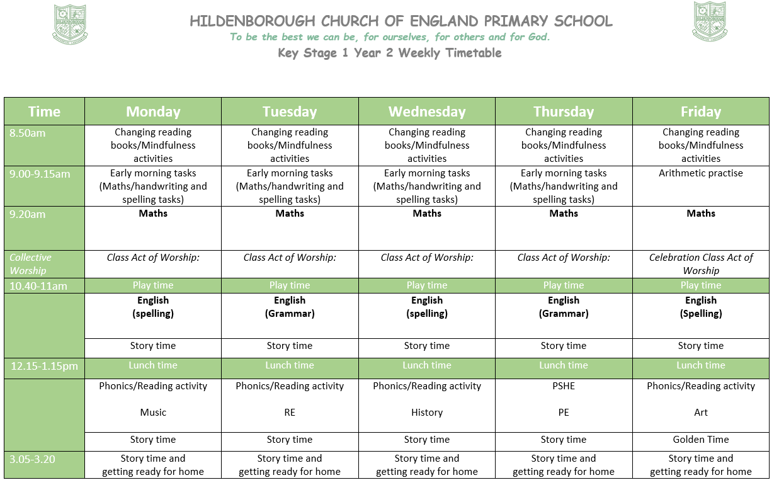

Behaviour systems/Golden Time
- In line with the school’s behaviour policy, we follow the traffic light system in class. If children reach ‘superstar’ status, they earn 3 house points.
- Golden Time happens on Friday afternoons-children can earn up to 30 minutes Golden Time each week for good behaviour and hard work.
- Children lose 2 minutes of Golden Time or play time each time they are moved down to orange or red-the time lost is used to reflect on and discuss their behaviour choices with the class teacher or a member of SLT.
- Star of the Week – A slip will come home with your child so that you know what they have earnt their star for.
Assessments
Next week, we will be completing short phonic screening check, this will enable us to support any children who have not quite secured phonetic knowledge prior to the government’s phonics screening test required before Christmas. In addition, we will be completing a series of short English and Maths assessments during the week beginning Monday September. These assessments will be used to identify and address any gaps as well as informing what interventions may need to be put in place.

How to help at home

Reading - Please listen to your child read every day. Reading scheme books will be changed once a week, this allows the children to have lots of practice with recognising and reading the words. Children will take home a reading record every week. Please record a comment to show that your child has been read with by an adult.

Spellings – We will be setting termly spellings linked to the statutory common exception words for Year 2. These will be sent home to parents in the coming weeks. Please practice these little and often with your child at home; we will also be practicing them in school. The children will be tested on these twice a term in the form of a ‘spelling challenge’.

Star of the day – Each week a child will be picked at random to be our class Star of the Week.

Maths – Look out for numbers in our environment and around the home is a fun way to practise skills. Examples are: door numbers, car number plates, road signs and whilst shopping or cooking. Practising number bonds is really useful too!

Water Bottles –Please make sure that your child comes to school with a named water bottle. We encourage the children to drink frequently to ensure they keep hydrated and we have alert children ready to learn. Please make sure it is water in the bottles.

Packed lunches and snacks – Please ensure all bags and pots are labelled.

P.E. Kits – At the beginning of each term, please send your child into school with their PE kits. with appropriate footwear for outdoor PE lessons.

Coats - Please ensure your child brings a named jumper/cardigan to school every day. Along with an appropriate named coat – now that the weather is turning cold.

We are looking forward to working with you to support your child’s progress this year. Any questions, please don’t hesitate to contact us.

Many thanks,

Year 2 team

