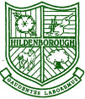
HILDENBOROUGH CHURCH OF ENGLAND PRIMARY SCHOOL
“I can do all things through Christ who strengthens me,” (Philippians 4:13) so that I can be the best that I can be, for myself, for others and for God.
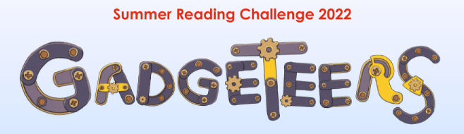

8th July 2022

Dear Parents,

The Summer Reading challenge starts this Saturday, 9th July. This fantastic scheme enables children to access a wide variety of books for FREE from our local participating libraries, including our one in Hildenborough!

Research shows that children's reading can dip during the long summer holidays if they do not have regular access to books and encouragement to read for pleasure. The Summer Reading Challenge is a fun and interactive way to encourage children to continue reading. The children will receive a poster and collect a series of stickers as they process through the scheme and be awarded a certificate at the end.

This year, the scheme is called the ‘Gadgeteers’ and is linked to the Science Museum. It is based on science and innovation and aims to spark the children’s curiosity about the world around them - which is really cool!

Library membership
Next week, all classes will be visiting the Hildenborough Library to sign up for this brilliant scheme. If your child is not already a member of the library, please complete the attached membership form and send it back into the school for Monday next week. The library staff will then process the membership so your child can take home books after their visit. If you would prefer, you can also sign up online here https://kent.spydus.co.uk/cgi-bin/spydus.exe/MSGTRN/WPAC/JOIN

If you have any queries, please do not hesitate to contact me via the school office.

Many thanks,

Johanna Morrish
Year 2 teacher, KS1 and English Lead

