Infant Agility years 1 and 2
For Infant Agility pupils take part in five activities: Pitcher, Jumper, Bouncer, Thrower and Runner.

- Jumper – this is Standing Long Jump.
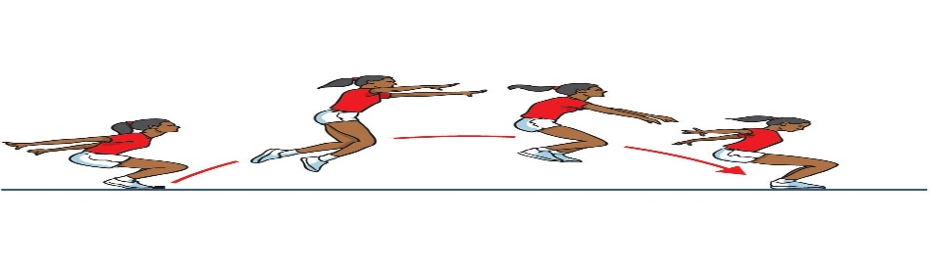
(STANDING LONG JUMP From a standing position, this is a two-footed jump. Pupils can practice this at home or in school with adequate space. Pupils should bend their knees to generate power and jump forwards landing on two feet. The measurement is taken from the back heel of the foot furthest back.)

- Thrower – this is Chest Push. Year 1&2 throw a size 4 Football.
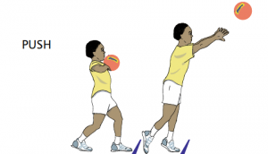
(CHEST PUSH A standing throw where the participant pushes a ball as far as they can. Pupils can practice with a football or similar at home. Pupils should either bend their knees and throw the ball when coming up or stand with one foot behind the other and transfer their weight from their back foot to their front foot when releasing the ball to generate power and a further throw!)

• Bouncer – this is Speed Bounce.
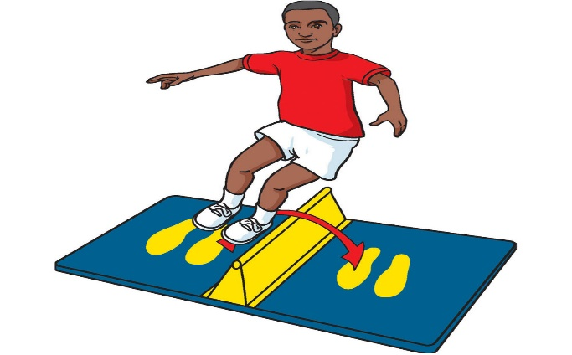
(SPEED BOUNCE Speed Bounce is a two-footed jump in which a pupil must take off and land on both feet – the athlete’s feet should leave the mat simultaneously and land on the mat simultaneously jumping over a wedge. Pupils can practice at home jumping over a line or similar – it would be great if they had something to represent the wedge, perhaps a pillow or something raised up that will NOT cause injury if they accidentally land on it! Pupils have 20 seconds to do as many jumps as possible!)

- Runner – 4 x 10 metre run/sprint (or for practice 8 x 5 metres if space is an issue). Pupils should run as fast as they can to get the best time.

• Pitcher – For this one, there should be a start line and cones should be placed at a distance from the start line at 2m, 2.5m, 3m, 3.5m and 4m. (Or just practice throwing bean bags or similar to targets).
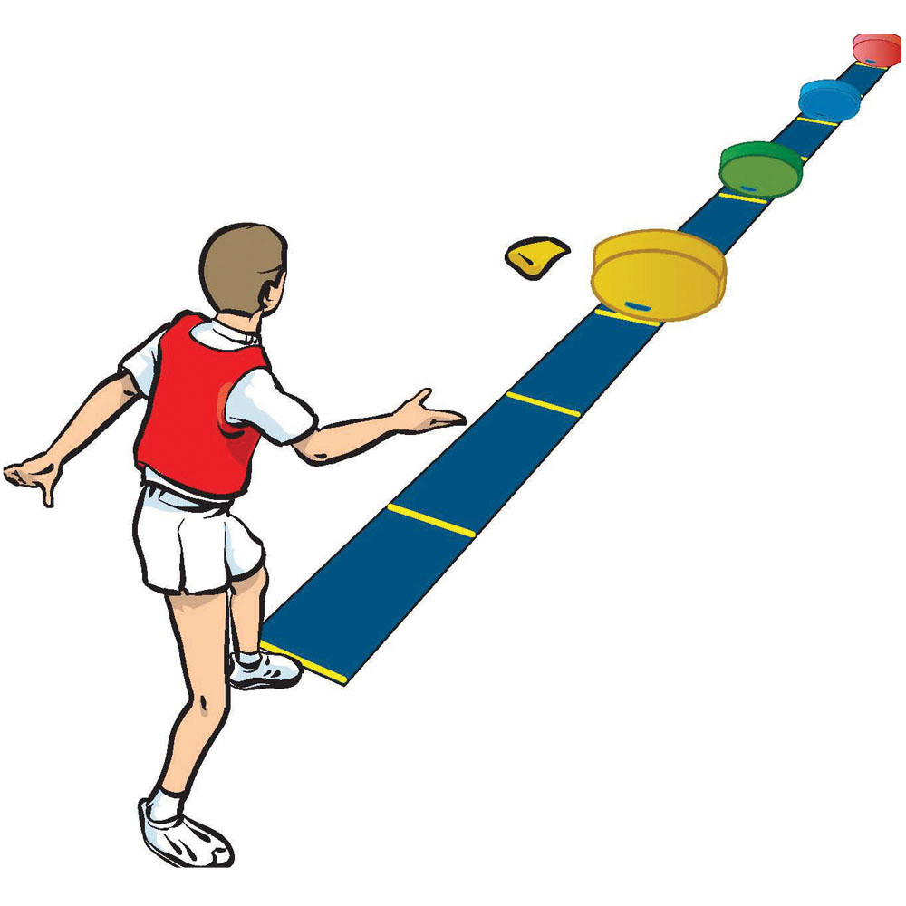
(The pupil stands behind the start line and must first throw 3 bean bags (or rolled up socks or soft toys) into the first target (the space between 2m – 2.5m). Once they have done this, they collect their bean bags and then attempt to throw all 3 of them into the next target (the space between 2.5 – 3m). Repeat until they have thrown all 3 bean bags in the 3.5m – 4m space. Pupils get one point for each bean bag in the correct area, if they are not in the correct area they do not get a point. Therefore the maximum number of points a pupil can get is 12 (3 points per target). )

