HILDENBOROUGH CHURCH OF ENGLAND PRIMARY SCHOOL
“I can do all things through Christ who strengthens me,” (Philippians 4:13) so that I can be the best that I can be, for myself, for others and for God.

Friday 28th January 2022

Dear Parents/Carers,

Children’s Mental Health Week 2022

We are delighted to be taking part in Children’s Mental Health Week, beginning Monday 7th February. The theme for the week is Growing Together and we have planned lots of activities around this to encourage our children to consider how they have grown, and how they can help others to grow. We will begin the week with our Book Exchange event (please see the letter sent on Friday 21st January for more details) and finish with a Dress to Express Day, on Friday 11th February. Children are invited to wear an outfit of their choice to express themselves; outfits can be as simple or elaborate as they like, and will be in exchange for a £1 donation to raise money for Place2Be.
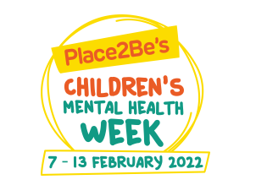

As part of the week, we have also arranged several activities that we would love for you to be involved in:
- Morning Mile – Join your child in completing the morning mile – what better way to start the day then a bit of fresh air and keep fit. Eighteen laps around the top playground and you will have completed the morning mile. However, please feel free to join in with as many or as few laps as you wish.
- Parents Coffee Morning – Stop for a tea or coffee (and biscuit!) after the morning drop off.
- Open Library – The school library will be open after school for you to stop and share a book with your child.
Monday 7th February | Tuesday 8th February | Wednesday 9th February | Thursday 10th February | Friday 11th February
8.30 - 8.45am  Morning Mile  3.15 - 4pm  Open Library | 3.15 - 4pm  Open Library | 8.30 - 8.45am  Morning Mile  3.15 - 4pm  Open Library | 9 – 9.30am  Parent’s Coffee  Morning  3.15 - 4pm  Open Library | 8.30 - 8.45am  Morning Mile  3.15 - 4pm  Open Library
We look forward to a fun-filled week and would like thank you in advance for your support and participation.

Best wishes,
Rachel Forward, Caroline Stone and Ruth Ardrey
Mental Health and Wellbeing Team

