 | TERM 1 | TERM 2 | TERM 3 |  | TERM 4 | TERM 5 | TERM 6
ENGLISH | A Poem To Be spoken silently and other poems  Poetry  Creating images in poetry/introduction to figurative language.  Shadow  Journey Tale  Conjunctions, sentence openers and structures.  Information Texts  Dogs-focus on applying different sentence types. | 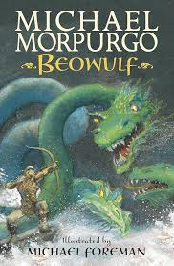  Beowulf by Michael Morpurgo  Outcome: Fiction – write a further adventure | 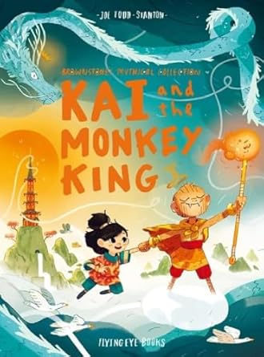  Kai and the Monkey King by Joe Todd-Stanton  Outcome:  Write a myth |  | 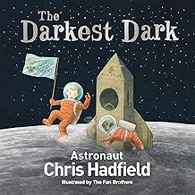  The Darkest Dark by Chris Hadfield  Outcome: Write a biography  Harry Potter  Outcome: Film scripts | 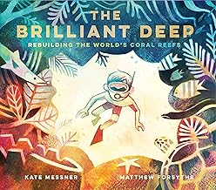  The Brilliant Deep by Kate Messner  Outcome:  Persuasion/information: write an information leaflet | 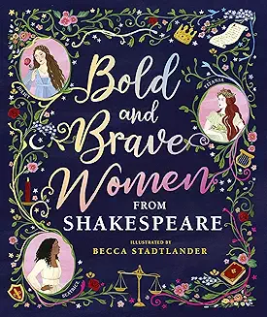  Bold and Brave Women from Shakespeare by Shakespeare Birthplace Trust  Outcome:  Write and perform a soliloquy
MATHS | Numbers to 1,000,000  Reading and writing, comparing, making number sequences and rounding numbers to 1,000,000.  Addition and Subtraction (whole numbers)  Adding and subtracting within 1,000,000.  Multiplication and Division (whole numbers)  Multiples, factors and primes. Multiplying and dividing by 10, 100 and 1000. Written methods for multiplication and division. | Multiplication and Division (whole numbers-continued)  Multiples, factors and primes. Multiplying and dividing by 10, 100 and 1000. Written methods for multiplication and division.  Word Problems (whole numbers). | Graphs  Read and interpret information in tables and in line graphs.  Fractions  Comparing and ordering fractions to solve problems.  Carrying out a range of operations with fractions. |  | Decimals  Reading and writing, comparing, adding and subtracting and round decimals.  Percentages  Finding percentages of quantities. | Geometry  Recognising and drawing angles. Solving problems involving angles.  Position and Movement  Translating and reflecting shapes. | Measurement  Converting units of: length, mass, time and telling the temperature.  Area and Perimeter  Finding perimeter and measuring and estimating area.  Volume  Volume of solids and capacity.  Roman Numerals  Roman Numerals to 1000.
RE | What does it mean if God is loving and holy?  God | Was Jesus the Messiah?  Incarnation | How can following God bring freedom and justice?  People of God |  | What did Jesus do to save human beings?  Salvation | What does it mean to be Muslim in Britain today?  Islam
SCIENCE | ’Earth and Space  ‘How significant are we in the universe?’ | Forces  ‘What would happen if there wasn’t any gravity on Earth? |  | Properties and changes of materials  ‘When we change a material, is it always forever?’ |  | Living things and their habitats  ‘Why are insects important in plant reproduction?’ | Animals including humans  ‘How is the life cycle of the butterfly like a human’s life cycle?  How does the average height of a class change as they get older?
COMPUTING | Online Safety |  | Creating Media  Stop Motion Animation |  |  | Programming  Micro:bit
HISTORY | Baghdad  The rise of Islam 900CE |  | The birth of the British Empire |  |  | Transatlantic Slave Trade
GEOGRAPHY |  | Spatial Sense |  |  | Mountains |  | Field Work: Local Study
ART | Style in Art and Design Rocco vs Modernism |  |  |  | Chinese Art
DT |  | Cooking and Nutrition  What could be healthier? |  |  |  | Digital World  Monitoring Devices (Cross-curricular DT and Computing unit)
MUSIC | Blues |  | South and West Africa |  |  | Production Music  (Singing)
PE/Forest School | Dance  Forest School | Gymnastics  Forest School | Hockey  Forest School |  | Handball  Forest School | Rounders  Forest School | Athletics  Forest School
SPANISH | Describing friends and family in Spanish |  | Spanish food and drink |  |  | A trip across Spain
PSHE | Relationships  Family and Relationships | Living in the Wider World  Citizenship | Living in the Wider World  Economic Wellbeing |  | Health and Wellbeing  Health and Wellbeing | Health and Wellbeing  Safety and the Changing Body
P4C | Shadow enquiry  Friendship enquiry | Rights and Responsibilities enquiry  Conserving the planet enquiry | Equality between males and females enquiry |  | Selflessness enquiry | History and English linked enquiries

