 | TERM 1 | TERM 2 |  | TERM 3 | TERM 4 | TERM 5 |  | TERM 6
ENGLISH | Meesha Makes Friends by Tome Percival  Diary Entry  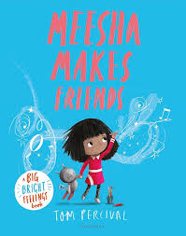 | Katie in London by James Mayhew  Non-chronological report  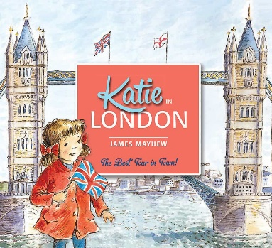 |  | The Lion Inside by Rachel Bright  Story writing | Beegu by Alexis Deacon  Writing own version of the story | Somebody Swallowed Stanley by Sarah Roberts  Non-Fiction: write information about the sea  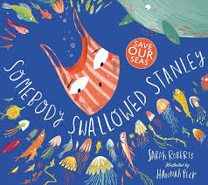 |  | A Midsummer Night’s Dream Adapted by Brooke Jorden  Character description
MATHS | Number and Place Value: Numbers to 10  Calculations – Addition and Subtraction within 10 | Geometry – Position and Direction: Positions  Number and Place Value: Numbers to 20  Calculations: Addition and Subtraction within 20 |  | Calculations: Addition and Subtraction within 20 continued  Geometry – Properties of Shape: Shapes and Patterns  Measurement: Height and Length  Revision and Remediation | Number and Place Value: Numbers to 40  Calculations: Addition and Subtraction  Calculations: Multiplication | Calculations: Multiplication and Division  Fractions  Number and Place Value: Numbers to 100 |  | Measurement: Time  Measurement: Money  Measurement: Volume and Capacity  Measurement: Mass  Geometry – Position and Direction: Space  Revision and Remediation
RE | Creation/Fall  What do Christians believe God is like? | Incarnation  Why does Christmas matter to Christians? |  | Gospel  What is the Good News that Jesus brings? | Salvation  Why does Easter matter to Christians? | Judaism  Who is Jewish and what do they believe?
SCIENCE | Everyday Materials  ‘Which material would be best to make a toy slide? | Seasonal Change |  | Animals including Humans  ‘What do all animals have in common?’ | Seasonal Change | Plants  ‘What would happen to a seed placed in a dark area? |  | Seasonal Change
COMPUTING | Online Safety |  |  | Computing Systems and Networks  Mouse Skills |  | Programming  Bee-Bots
HISTORY | Discovering History |  |  |  | Kings, Queens and Leaders
GEOGRAPHY |  |  | Spatial |  |  |  | The UK
ART | Line  Line Drawings |  |  | Colour  Paint Mixing- Primary and Secondary Colours |  | Investigating Sculpture  Carving and Casting
DESIGN AND TECHNOLOGY |  | Structures  Constructing a Windmill |  |  | Healthy Eating  Designing a balanced healthy wrap
MUSIC | Nativity |  |  | Pitch  Super Heroes |  | Musical Symbols  Under the sea
PE | Hit, Catch, Run  (Unit 1) | Gymnastics  (Unit 1) |  | Dance  (Unit 1) | Attack, Defend, Shoot  (Unit 1) | Run, Jump Throw  (Unit 1) |  | Athletics (Sports day)
PSHE | Relationships  Family and Relationships | Living in the Wider World  Citizenship |  | Living in the Wider World  Economic Wellbeing | Health and Wellbeing  Health and Wellbeing | Health and Wellbeing  Safety and the Changing Body  Transition  Year 1 Transition

